## PROJECT REPORT

#### On

# LAWYERS CONNECT

##### Submitted to MAHARAJA RANJIT SINGH PUNJAB TECHNICAL UNIVERSITY in partial fulfillment of the requirement for the award of the degree of

**B.TECH**

#### in

**COMPUTER SCIENCE & ENGINEERING**

### Submitted By

**HARASIS SINGH, HARPREET SINGH, HARPREET SINGH**

**Roll.No.- 160280032,160280034,160280035**



#### DEPARTMENT OF COMPUTER SCIENCE & ENGINEERING

#### GIANI ZAIL SINGH COLLEGE CAMPUS OF ENGINEERING& TECHNOLOGY, MRSPTU, BATHINDA-151001

**DECEMBER 2019**

## PROJECT REPORT

#### On

# LAWYERS CONNECT

##### Submitted to to MAHARAJA RANJIT SINGH PUNJAB TECHNICAL UNIVERSITY in partial fulfillment of the requirement for the award of the degree of

**B.TECH**

#### in

**COMPUTER SCIENCE & ENGINEERING**

### Submitted By

**HARASIS SINGH, HARPREET SINGH, HARPREET SINGH**

**Roll.No.- 160280032, 160280034, 160280035**



#### DEPARTMENT OF COMPUTER SCIENCE & ENGINEERING

#### GIANI ZAIL SINGH COLLEGE CAMPUS OF ENGINEERING & TECHNOLOGY, MRSPTU, BATHINDA-151001

**DECEMBER 2019**

**PREFACE**

This record is concerned about our project during the 7th semester of our B.Tech. We have built our Project in **Web Development.** During this project, we got to learn many new things about the industry and the current requirements of companies. This project proved to be a milestone in our knowledge of present industry. Every say and every moment was an experience in itself, an experience which theoretical study can’t provide.

**ACKNOWLEDGEMENT**

It is our pleasure to be indebted to various people, who directly or indirectly contributed in the development of this work and who influenced my thinking, behavior and acts during the course of study.

We express our sincere gratitude to ***Dr. Dinesh Kumar*** worthy HOD and mentor for this major project in the 7th semester our B.Tech.

We am thankful to ***Dr.Dinesh Kumar*** for his support, cooperation, and motivation provided to us during the project for constant inspiration, presence and blessings.

Lastly, we would like to thank the almighty and our parents for their moral support and our friends with whom we shared our day-to day experience and received lots of suggestions for the quality of work.

**HARASIS SINGH GILL**

**HARPREET SINGH**

**HARPREET SINGH CHAHAL**

## CANDIDATE’S DECLARATION

I, HARASIS SINGH GILL, HARPREET SINGH, HARPREET SINGH CHAHAL Roll No. 160280032,160280034,160280035, B.Tech (Semester- VII) of the **Gaini Zail Singh Campus College of Engineering & Technology, Bathinda** hereby declare that the Project Report entitled **“LAWYERS CONNECT”** is an original work and data provided in the study is authentic to the best of our knowledge. This report has not been submitted to any other Institute for the award of any other degree.

**HARASIS SINGH GILL**

(Roll No.-160280032)

**HARPREET SINGH**

(Roll No.-160280034)

**HARPREET SINGH CHAHAL**

**(**Roll No.-160280035**)**

**TABLE OF CONTENTS**

|  |  |  |
| --- | --- | --- |
| **Chapter** | **Contents** | **Page No.** |
| 1 | Abstract | 7 |
| 2 | Introduction to PHP | 8 |
|  | * What did you learn? | 8 |
|  | * Advantages of PHP | 8 |
|  | * Scope of PHP | 9 |
|  | * Report Organization | 9 |
| 3 | Introduction to Technologies | 10 |
|  | * HTML | 10 |
|  | * Cascading Style Sheet 3(CSS3) | 16 |
|  | * PHP | 17 |
|  | * JAVASCRIPT | 24 |
| 4 | Introduction to the Project | 29 |
|  | * Introduction | 29 |
|  | * Working of Project | 29 |
|  | * Benefits of Project | 29 |
|  | * Technologies Used | 31 |
| 5 | Methodology | 32 |
| 6 | Flow Diagram | 33 |
| 7 | ScreenShots | 34-44 |
| 8 | Conclusion | 45 |
| 9 | Bibliography | 46 |
|  |  |  |
|  |  |  |
|  |  |  |
|  |  |  |
|  |  |  |
|  |  |  |
|  |  |  |
|  |  |  |
|  |  |  |
|  |  |  |
|  |  |  |
|  |  |  |

**1.Abstract**

Project work is major part of course. It is a period in which we are introduced to the actual process of making a project successful. In other words, we can say that project lab course training is provided for the familiarization with the environment in which the development of an actual project is done. In the department of computer engineering, we are introduced with the process of software engineering, which is we owe and includes not only the process but actual process of software development.

During the period of B.Tech in computer engineering, 7th semester, we have studied all the theoretical subjects, which are required for the development of software or some other design. But this is the time when we put our knowledge to actual work and learn how to combine all the aspects of software engineering.

The objectives of doing project work is to raise the level of performance in one or more of its aspects and this may be achieved by careful learning of the process of software engineering. Furthermore motivation for new learning of group relation, coordination and cooperation provides an overview of the total development process.

Project work is an important part of theoretical studies. It covers all that remains incurred in the classroom i.e. without it out studies remains ineffective and incomplete. Also it explores a student to own invaluable creasier of experience and offer an exposure to real management in an organization.

**2.Introduction to PHP**

**What did you learn?**

**PHP** is a [general-purpose](http://en.wikipedia.org/wiki/General-purpose_programming_language) [server-side scripting](http://en.wikipedia.org/wiki/Server-side_scripting) language originally designed for [Web development](http://en.wikipedia.org/wiki/Web_development) to produce [dynamic Web pages](http://en.wikipedia.org/wiki/Dynamic_Web_page). It is one of the first developed server-side scripting languages to be embedded into an [HTML](http://en.wikipedia.org/wiki/HTML)source document rather than calling an external file to process data. The code is [interpreted](http://en.wikipedia.org/wiki/Interpreter_%28computing%29) by a Web server with a PHP processor module which generates the resulting Web page. It also has evolved to include a [command-line interface](http://en.wikipedia.org/wiki/Command-line_interface) capability and can be used in [standalone](http://en.wikipedia.org/wiki/Computer_software) [graphical applications](http://en.wikipedia.org/wiki/Graphical_user_interface). PHP can be deployed on most Web servers and also as a standalone [shell](http://en.wikipedia.org/wiki/Shell_%28computing%29) on almost every [operating system](http://en.wikipedia.org/wiki/Operating_system) and [platform](http://en.wikipedia.org/wiki/Computing_platform) free of charge. A competitor to [Microsoft](http://en.wikipedia.org/wiki/Microsoft)'s [Active Server Pages](http://en.wikipedia.org/wiki/Active_Server_Pages) (ASP) server-side script engine and similar languages, PHP is installed on more than 20 million Web sites and 1 million [Web servers](http://en.wikipedia.org/wiki/Web_server). Software that uses PHP includes [MediaWiki](http://en.wikipedia.org/wiki/MediaWiki), [Joomla](http://en.wikipedia.org/wiki/Joomla), [Wordpress](http://en.wikipedia.org/wiki/Wordpress), [Concrete5](http://en.wikipedia.org/wiki/Concrete5), [MyBB](http://en.wikipedia.org/wiki/MyBB), and [Drupal](http://en.wikipedia.org/wiki/Drupal).

**Advantages of php**

* PHP is accessible
* It's available for free
* It's available with documentation in many languages
* There are many support groups, forums, and teams supporting PHP
* There is a wealth of online information regarding PHP
* It's quick to develop in PHP
* PHP is loosely typed, which makes basic scripts much faster to develop with less attention to design
* PHP is flexible. Use OOP or not. Use naming convention(s) or not
* It runs on many different operating systems
* It can be optimized, even "compiled" for performance closer to that of more established compiled languages.

**What is the scope of php?**

If your are planning to build your career in Web technology then PHP is the best programming scripting language to learn and is also a good career option. PHP is basically a scripting language used for web development. The websites created by PHP are dynamic and attractive. So, Because of this reason it is demanded the most in web technology. PHP is an open source so is used freely without any cost and so greatly in demand.

Scope in PHP really high as PHP is a language knows in the world of technology since many years. So it has gained the maximum popularity in this era.

**Report organization**

This report is divided in three chapters. First chapter is about general introduction in which the introduction of the company, their objectives, introduction and advantages of the language which we learnt in the company and scope of the language is covered.

Second chapter is about the language which we learnt in the company while training. It covers whole the work undertaken during the training time.

Third chapter is about project undertaken in which introduction of project i.e. “LAWYERS CONNECT” is specified and project’s snapshots are also given in this chapter. At the end references are provided which helped us to learn the language.

**3. Introduction to Technologies**

**What is HTML?**

HTML is a language for designing web pages.

* HTML stands for Hyper Text Markup Language.
* HTML is not a programming language, it is a markup language.
* A markup language is a set of markup tags.

**a) HTML Tags**

HTML markup tags are usually called HTML tags

* HTML tags are keywords surrounded by angle brackets like <html>
* HTML tags normally come in pairs like <b> and </b>
* The first tag in a pair is the start tag, the second tag is the end tag.
* Start and end tags are also called opening tags and closing tags.

**b)HTML Headings**

HTML headings are defined with the <h1> to <h6> tags.

**Example**

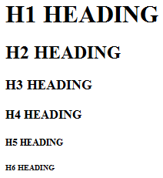

**c)HTML Paragraphs**

HTML paragraphs are defined with the <p> tag.

**Example**

<p>This is a paragraph</p>

<p>This is another paragraph</p>

**d)HTML Links**

HTML links are defined with the <a> tag.

**Example**

<a href="http://www.w3schools.com">This is a link</a>

**e)HTML Images**

HTML images are defined with the <img> tag.

**Example**

<imgsrc="constr4.gif" width="144" height="50" />

**f)HTML Elements**

An HTML element is everything from the start tag to the end tag**:**

|  |  |  |
| --- | --- | --- |
| **START TAG** | **ELEMENT CONTENT** | **END TAG** |
| <p> | This is a paragraph | </p> |
| <a href="default.htm" > | This is a link | </a> |

**HTML Element Syntax**

* An HTML element starts with a start tag.
* An HTML element ends with an end tag.
* The element content is everything between the start and end tag.
* Some HTML elements have empty content.
* Some HTML elements have a missing end tag.

**g)HTML Attributes**

* HTML elements can have attributes.
* Attributes provide additional information about the element.
* Attributes are always specified in the start tag.

**h)HTML Style Examples**

style="background-color:yellow"

style="font-size:10px"

style="font-family:Times"

style="text-align:center"

**i) The Image Tag and the Src Attribute**

In HTML, images are defined with the <img> tag.  The <img> tag is empty, which means that it contains attributes only and it has no closing tag.

To display an image on a page, you need to use the src attribute. Src stands for "source". The value of the src attribute is the URL of the image you want to display on your page.

The syntax of defining an image:

<imgsrc="url" />

**j)The Alt Attribute**

The alt attribute is used to define an "alternate text" for an image if image is not loaded.

<imgsrc="boat.gif" alt="Big Boat" />

The "alt" attribute tells the reader what he or she is missing on a page if the browser can't load images.

**k)Tables**

Tables are defined with the <table> tag. A table is divided into rows (with the <tr> tag), and each row is divided into data cells (with the <td> tag). The letters td stands for "table data," which is the content of a data cell. A data cell can contain text, images, lists, paragraphs, forms, horizontal rules, tables, etc.

Example:-

<table border="1">

<tr>

<td>row 1, cell 1</td>

<td>row 1, cell 2</td>

</tr>

<tr>

<td>row 2, cell 1</td>

<td>row 2, cell 2</td>

</tr>

</table>

Browser Preview:



**Headings in a Table**

Headings in a table are defined with the <th> tag.

Example:-

<table border="1">

<tr>

<th>Heading</th>

<th>Another Heading</th>

</tr>

<tr>

<td>row 1, cell 1</td>

<td>row 1, cell 2</td>

</tr>

<tr>

<td>row 2, cell 1</td>

<td>row 2, cell 2</td>

</tr>

</table>

9

Browser Preview:

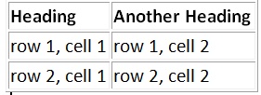

**l)Forms**

A form is an area that can contain form elements.

Form elements are elements that allow the user to enter information (like text fields, textarea fields, drop-down menus, radio buttons, checkboxes, etc.) in a form.

A form is defined with the <form> tag.

**Input**

The most used form tag is the <input> tag. The type of input is specified with the type attribute. The most commonly used input types are explained below.

**Text Fields**

Text fields are used when you want the user to type letters, numbers, etc. in a form.

<form>

First name: <input type="text" name="firstname"><br>

Last name: <input type="text" name="lastname">

</form>

How it looks in a browser:

Top of Form

Firstname:  
Last name: 

**Radio Buttons**

Radio Buttons are used when you want the user to select one of a limited number of choices.

<form>

<input type="radio" name="sex" value="male"> Male<br>

<input type="radio" name="sex" value="female"> Female

</form>

**How it looks in a browser:**

Top of Form

Male   
Female

Bottom of Form

Note that only one option can be chosen.

**Checkboxes**

Checkboxes are used when you want the user to select one or more options of a limited number of choices.

<form>

I have a bike:<input type="checkbox" name="vehicle" value="Bike"><br>

I have a car: <input type="checkbox" name="vehicle" value="Car"><br>

I have an airplane: <input type="checkbox" name="vehicle" value="Airplane">

</form>

**How it looks in a browser:**

ComputerTop of Form

Computer:  
Laptop:  
Palmtop: 

Bottom of Form

**The Form's Action Attribute and the Submit Button**

When the user clicks on the "Submit" button, the content of the form is sent to the server. The form's action attribute defines the name of the file to send the content to. The file defined in the action attribute usually does something with the received input.

<form name="input" action="html_form_submit.php" method="get">

Username: <input type="text" name="user">

<input type="submit" value="Submit">

</form>

**How it looks in a browser:**

Top of Form

Username: 

Bottom of Form

If you type some characters in the text field above, and click the "Submit" button, the browser will send your input to a page called "html_form_submit.php". The page will show you the received input.

**Cascading Style Sheets 3** (**CSS3**)

**Cascading Style Sheets** (**CSS3**) is a [style sheet language](http://en.wikipedia.org/wiki/Style_sheet_language) used for describing the [presentation semantics](http://en.wikipedia.org/wiki/Presentation_semantics) (the look and formatting) of a document written in a [markup language](http://en.wikipedia.org/wiki/Markup_language). Its most common application is to style [web pages](http://en.wikipedia.org/wiki/Web_page) written in [HTML](http://en.wikipedia.org/wiki/HTML) and [XHTML](http://en.wikipedia.org/wiki/XHTML), but the language can also be applied to any kind of [XML](http://en.wikipedia.org/wiki/XML) document, including [plain XML](http://en.wikipedia.org/wiki/Plain_Old_XML), [SVG](http://en.wikipedia.org/wiki/Scalable_Vector_Graphics) and [XUL](http://en.wikipedia.org/wiki/XUL).

CSS is designed primarily to enable the separation of document content (written in HTML or a similar markup language) from document presentation, including elements such as the layout, colors, and fonts. This separation can improve content [accessibility](http://en.wikipedia.org/wiki/Accessibility), provide more flexibility and control in the specification of presentation characteristics, enable multiple pages to share formatting, and reduce complexity and repetition in the structural content (such as by allowing for [tableless web design](http://en.wikipedia.org/wiki/Tableless_web_design)). CSS can also allow the same markup page to be presented in different styles for different rendering methods, such as on-screen, in print, by voice (when read out by a speech-based browser or [screen reader](http://en.wikipedia.org/wiki/Screen_reader)) and on [Braille](http://en.wikipedia.org/wiki/Braille)-based, [tactile](http://en.wikipedia.org/wiki/Tactile) devices. It can also be used to allow the web page to display differently depending on the screen size or device on which it is being viewed. While the author of a document typically links that document to a CSS style sheet, readers can use a different style sheet, perhaps one on their own computer, to override the one the author has specified.

CSS specifies a priority scheme to determine which style rules apply if more than one rule matches against a particular element. In this so-called *cascade*, priorities or *weights* are calculated and assigned to rules, so that the results are predictable.CSS files can be associated with HTML documents using the following syntax:

<linkrel="stylesheet"href="http://example.com/css/style.css"type="text/css"/>

**example:-**div span, p span,nav span{

font-size:18px;

}

**What is PHP?**

PHP is a powerful server side scripting language originally designed for web development to produce dynamic web pages. For this purpose, PHP code is embedded into the HTML source document and interpreted by a web server with a PHP processor module, which generates the web page document. It also has evolved to include a command-line interface capability and can be used in standalone graphical applications. PHP can be deployed on most web servers and as a standalone interpreter, on almost every operating system and platform free of charge. PHP is installed on more than 20 million websites and 1 million web servers.

PHP was originally created by RasmusLerdorf in 1995. PHP primarily acts as a filter, taking input from a file or stream containing text and/or PHP instructions and outputs another stream of data; most commonly the output will be HTML.

Latest version of PHP is 5.3.6. A new major version has been under development alongside PHP 5 for several years. This version was originally planned to be released as PHP 6 as a result of its significant changes, but later they dropped the plan and move on to develop PHP 5.4.0.

|  |  |
| --- | --- |
| **Structure** | **Object-oriented, Procedural** |
| Appeared in | 1995 |
| Latest Stable Release | 5.5. |
| Influenced by | C, Perl, Java, C++ |
| OS | Cross-Platform |
| License | PHP License |
| File Extension | .php .html |

**Basic Syntax of PHP**

A PHP scripting block always starts with <?php and ends with ?>. A PHP scripting block can be placed anywhere in the document.

<?php?>1

A PHP file normally contains HTML tags, just like an HTML file, and some PHP scripting code.

Below, we have an example of a simple PHP script which sends the text "Hello World" to the browser:

<html>

<body>

<?phpecho "Hello World";?>

</body>

</html>

**PHP Variables**

In PHP, a variable does not need to be declared before adding a value to it.

$var_name = value;

We do not have to tell PHP which data type the variable is.String variables are used for values that contain characters.

$txt="Hello World";

**The Concatenation Operator**

There is only one string operator in PHP.

The concatenation operator (.)  is used to put two string values together.

To concatenate two variables together, use the dot (.) operator:

<?php

$txt1="Hello World";

$txt2="1234";

echo $txt1 . " " . $txt2;

?>

**Output:**

Hello World 1234

**ConditionalStatements**

* **Switch Statement**

Use the switch statement to select one of many blocks of code to be executed.

switch(*n*)  
{

Case 1: Code;

break;

Case 2: Code;

break;

default: Code;

}

* **If Else Statement**

Use the if statement to execute some code only if a specified condition is true.

if(condition)

codeto be executed if condition is true;

else  
code to be executed if condition is false;

**Loops**

In PHP, we have the following looping statements:

* **while**- loops through a block of code while a specified condition is true

while(*condition*){

*code to be executed*;

}

* **do...while** - loops through a block of code once, and then repeats the loop as long as a specified condition is true

do {

code to be executed;

}

while (condition);

* **for**- loops through a block of code a specified number of times

for(initilize; condition; increment/decrement){

code to be executed;

}

* **foreach**- loops through a block of code for each element in an array

foreach ($array as $value){

code to be executed;

}

**PHP Functions**

Create a PHP Function

A function is a block of code that can be executed whenever we need it.

**Creating PHP functions:**

* All functions start with the word "function()"
* Name the function - It should be possible to understand what the function does by its name. The name can start with a letter or underscore (not a number)
* Add a "{"  - The function code starts after the opening curly brace
* Insert the function code
* Add a "}"  - The function is finished by a closing curly brace

Example

A simple function that writes my name when it is called:

<html>

<body>

<?php

functionwriteMyName()

{

echo "Kai Jim Refsnes";

}

writeMyName();

?>

</body>

</html>

**Use a PHP Function**

Now we will use the function in a PHP script:

<html>

<body>

<?php

functionwriteMyName()

{

echo "Sukhdeep";

}

echo "Hello world!<br />";

echo "My name is ";

writeMyName();

echo ".<br />That's right, ";

writeMyName();

echo " is my name.";

?>

</body>

</html>

The output of the code above will be:

Hello world!

My name is Sukhdeep.

That's right, Sukhdeep is my name.

**PHP Sessions**

A PHP session variable is used to store information about, or change settings for a user session. Session variables hold information about one single user, and are available to all pages in one application.

Before you can store user information in your PHP session, you must first start up the session.

*session_start();*

The correct way to store and retrieve session variables is to use the PHP $_SESSION variable:

*$_SESSION[‘varname’]=‘Hello’;*

You can completely destroy the session by calling the *session_destroy()* function.

Session is valid only until the user has kept the webpage opened in the browsers, one the user closes the tab or goes to another site, the session expires and all values are unset.

**PHP Cookies**

A cookie is often used to identify a user. A cookie is a small file that the server embeds on the user's computer. Each time the same computer requests a page with a browser, it will send the cookie too. With PHP, you can both create and retrieve cookie values.

The *setcookie()* function is used to set a cookie.

*setcookie(name, value, expire, path, domain);*

The PHP *$_COOKIE* variable is used to retrieve or Insert a cookie value:

*$_COOKIE[‘varname’]=‘HELLO’;*

When deleting a cookie you should assure that the expiration date is in the past.

<?php  
// set the expiration date to one hour ago

setcookie("user", "", time()-3600);?>

**PHP with MySQL**

Before you can access data in a database, you must create a connection to the database.

mysql_connect(servername,username,password);

Usually Server is localhost when you are using it from a local machine. And default username and password are ‘root’ and NULL.

The CREATE DATABASE statement is used to create a database in MySQL.

*CREATE DATABASE database_name*

The CREATE TABLE statement is used to create a table in MySQL.

*CREATE TABLE table_name  
(  
column_name1 data_type, ....  
)*

**Inserting into Database**

The mysql_select_db() statement is used to select from a database server.

*mysql_select_db(‘database_name’, $connection_var);*

The INSERT INTO statement is used to add new records to a database table.

*INSERT INTO table_name  
VALUES (value1, value2, value3,...)*

Example:

*mysql_query("INSERT INTO Persons (FirstName, LastName, Age)  
VALUES ('Peter', 'Griffin', '35')");*

**SELECT Statement**

The SELECT statement is used to select data from a database.

*SELECT* column_name(s) *FROM table_name*

**The WHERE clause is used to filter records.**

***SELEC****T* column_name(s)  
FROM table_name  
*WHERE column_name operator value*

**The ORDER BY keyword is used to sort the data in a recordset.**

SELECT column_name(s)  
FROM table_name  
ORDER BY column_name(s) ASC|DESC

**MySQL Update and Delete**

The UPDATE statement is used to update existing records in a table.

*UPDATE table_name  
SET column1=value, column2=value2,...  
WHERE some_column=some_value*

The DELETE FROM statement is used to delete records from a database table.

*DELETE FROM table_name  
WHERE some_column = some_value*

**Javascript**

JavaScript (sometimes abbreviated JS) is a programming language that is widely used to give sophisticated functionality to web pages. It is also used occasionally in non-web-related applications—for example in PDF documents, site-specific browsers, and desktop widgets. JavaScript copies many names and naming conventions from the programming language Java, but the two languages are otherwise unrelated and have very different semantics.JavaScript is a prototype-based scripting language that is dynamic, weakly typed and has first-class functions. It uses syntax influenced by the language C. The key design principles within JavaScript are taken from the Self and Scheme programming languages. It is a multi-paradigm language, supporting object-oriented,imperative, and functional programming styles.

**Example:-**

<html>

<head>

<body>

<script type="text/javascript">

<!—

**function**prompter**(){**

**var**reply=prompt**(**"hey there, good luking stranger ! whats your name?" , ""**)**

alert**(**"nice to see you around these parts" + reply +"!"**)**

**}**

//-->

</script>

</head>

</body>

<form>

<input type="button" onclick="prompter()" value="wassup">

</form>

</html>

**a) JQuery**

JQuery is a multi-browser JavaScript library designed to simplify the client-side scripting of HTML. It was released in January 2006 at BarCamp NYC by John Resig. It is currently developed by a team of developers led by Dave Methvin. Used by over 55% of the 10,000 most visited websites, JQuery is the most popular JavaScript library in use today.

JQuery is free, open source software, licensed under the MIT License. JQuery's syntax is designed to make it easier to navigate a document, select DOM elements, create animations, handle events, and develop Ajax applications. JQuery also provides capabilities for developers to create plug-ins on top of the JavaScript library.

This enables developers to create abstractions for low-level interaction and animation, advanced effects and high-level, theme-able widgets. The modular approach to the JQuery library allows the creation of powerful dynamic web pages and web applications.

**Example:-**

<html>

<head>

<style>

div { background**:**#cfd**;** margin**:**3px**;** width**:**50px**;**

text-align**:**center**;**float**:**left**;**

input { display**:**none**;** width**:**120px**;**float**:**left**;**

margin**:**10px**;** }

</style>

<scriptsrc="jquery-1.7.2.js"></script>

</head>

<body>

<div>Push!</div>

<input type="text" class="middle" />

<input type="text" class="middle" />

<input type="text" class="middle" />

<script>

$**(**"div"**)**.click**(function () {**

$**(this)**.css**({** borderStyle:"inset", cursor:"wait" **})**;

$**(**"input"**)**.slideDown**(**2000,**function(){**

$**(this)**.css**(**"border", "2px red inset"**)**

.filter**(**".middle"**)**

.css**(**"background", "yellow"**)**

.focus**()**;

$**(**"div"**)**.css**(**"visibility", "hidden"**)**;

**})**;

**})**;

</script>

</body>

</html>

**b)Ajax**

Ajax (also AJAX; an acronym for Asynchronous JavaScript and XML) is a group of interrelated web development techniques used on the client-side to create asynchronous web applications. With Ajax, web applications can send data to, and retrieve data from, a server asynchronously (in the background) without interfering with the display and behavior of the existing page. Data can be retrieved using the XMLHttpRequest object. Despite the name, the use of XML is not required (JSON is often used instead), and the requests do not need to be asynchronous.

Ajax is not a single technology, but a group of technologies. HTML and CSS can be used in combination to mark up and style information. The DOM is accessed with JavaScript to dynamically display, and to allow the user to interact with the information presented. JavaScript and the XMLHttpRequest object provide a method for exchanging data asynchronously between browser and server to avoid full page reloads.

**XAMPP:** XAMPP is a free and open source cross-platform web server solution stack package, consisting mainly of the Apache HTTP Server, MySQL database, and interpreters for scripts written in the PHP and Perl programming languages.XAMPP also provides support for creating and manipulating databases in MySQL and SQLite among others.

**MySQL:** SQL is a special-purpose language used to define, access, and manipulate data. SQL is *nonprocedural*, meaning that it describes the necessary components (i.e., tables) and desired results without dictating exactly how those results should be computed. Every SQL implementation sits atop a *database engine*, whose job it is to interpret SQL statements and determine how the various data structures in the database should be accessed to accurately and efficiently produces the desired outcome.

* MySQL is a database system used on the web
* MySQL is a database system that runs on a server
* MySQL is ideal for both small and large applications
* MySQL is very fast, reliable, and easy to use
* MySQL uses standard SQL
* MySQL compiles on a number of platforms
* MySQL is free to download and use
* MySQL is developed, distributed, and supported by Oracle Corporation
* MySQL is named after co-founder Monty Widenius's daughter: My

The data in a MySQL database are stored in tables. A table is a collection of related data, and it consists of columns and rows.We are working on back end with MS-SQL SERVER 2005 for database connectivity.The SQL language includes two distinct sets of commands: *Data Definition Language* (DDL) is the subset of SQL used to define and modify various data structures, while *Data Manipulation Language* (DML) is the subset of SQL used to access and manipulate data contained within the data structures

previously defined via DDL. DDL includes numerous commands for handling such tasks as creating tables, indexes, views, and constraints, while DML is comprised of just five statements:

**INSERT*:*** Adds data to a database.

**UPDATE:** Modifies data in a database.

**DELETE:** Removes data from a database.

**SELECT:**  Retrieves data from a database.

SQL can be divided into two parts: The Data Manipulation Language (DML) and the Data Definition Language (DDL).The query and update commands form the DML part of SQL:

* **SELECT** - extracts data from a database
* **UPDATE** - updates data in a database
* **DELETE** - deletes data from a database
* **INSERT INTO** - inserts new data into a database

**4.Introduction To Project**

Our Project “Lawyers Connect” is a website which behaves like a Interface Between a Client and Lawyer. You can access our services by Signing up as a client or lawyer. Our Website provides you a list of Various Categories of Lawyers. You can communicate with lawyers via their Contact Number and Email Address..

**Working Of Project**

* Our website services are accessible to the registered users and you can register yourself by signing up as lawyer or client.
* After logging up as client , you can choose category of lawyer you want, then a list of lawyers of the chosen category will be displayed. Clients can contact lawyers via their mobile number or email address.
* After logging up as a lawyer , you can access your profile , you can update and save your details. You have to set your category , mobile number , email address , chamber number etc.

**Benefits of Project**

* It is based on real life.
* Less time consumption in searching a lawyer.
* Lawyers and clients can communicate easily.
* No registration cost.
* You can search for various types of lawyers.
* It is a lawyer based as well as client based website.

**Technologies Used**

* HTML
* CSS
* JSON
* PHP
* AJAX
* ANGULAR JS
* JAVA SCRIPT
* JQuery

**XAMPP & MYSQL**

**XAMPP:** XAMPP is a free and open source cross-platform web server solution stack package, consisting mainly of the Apache HTTP Server, MySQL database, and interpreters for scripts written in the PHP and Perl programming languages.XAMPP also provides support for creating and manipulating databases in MySQL and SQLite among others.

**MySQL:** SQL is a special-purpose language used to define, access, and manipulate data. SQL is *nonprocedural*, meaning that it describes the necessary components (i.e., tables) and desired results without dictating exactly how those results should be computed. Every SQL implementation sits atop a *database engine*, whose job it is to interpret SQL statements and determine how the various data structures in the database should be accessed to accurately and efficiently produces the desired outcome.

**5.Methodology**

|  |
| --- |
|  |

**1 Project identification and selection**

In this phase the project information system needs are identified and analyzed such as identified the title of the project.

**2 Project initiation and planning**

During this phase the Gantt chart has been developed as a time line to determining the task involve in developing project.

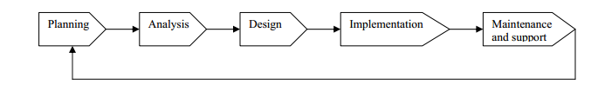

Fig.8.1 Stages of Methodology

**3 Analysis**

In the phase, the real life problem to manage information is studies by collecting the information through the people and analyzed the information to get alternatives for the use of proposed system.

**4 Design**

Logical design is the fourth phase in SDLC methodology. The functional features chosen for the proposed system in Analysis phase are described. Part of the logical design of the information system is to devise the user interface. The interface plays an important role to connect the resident with the system and is thus extremely important.

**5 Code Generation**

The design must be translated into a machine readable form. The code generation step performs this risk. The design part is translated into coding part by using some programming languages.

**6.Flow Diagram (Design)**

**LOGIN AS CLIENT**

**LOG IN AS LAWYER**

**7.SCREENSHOTS**





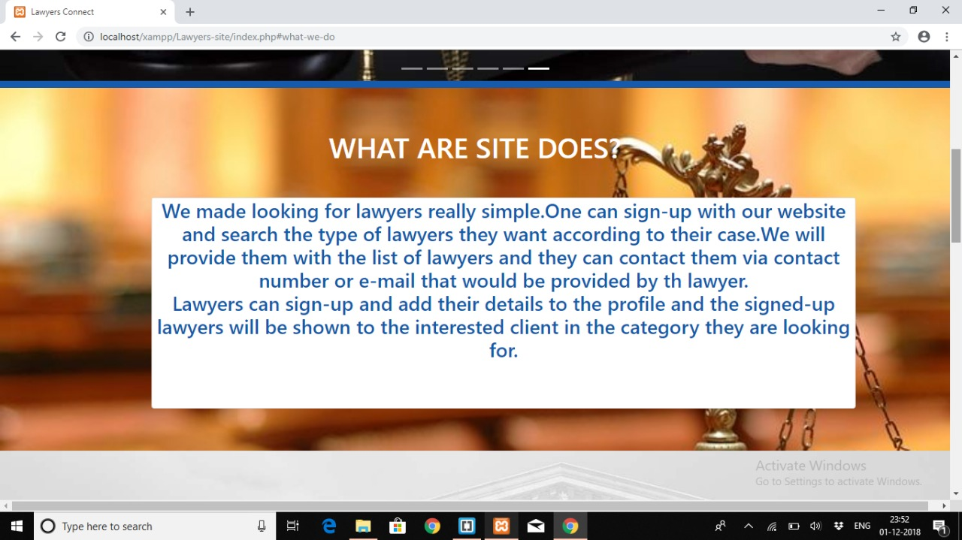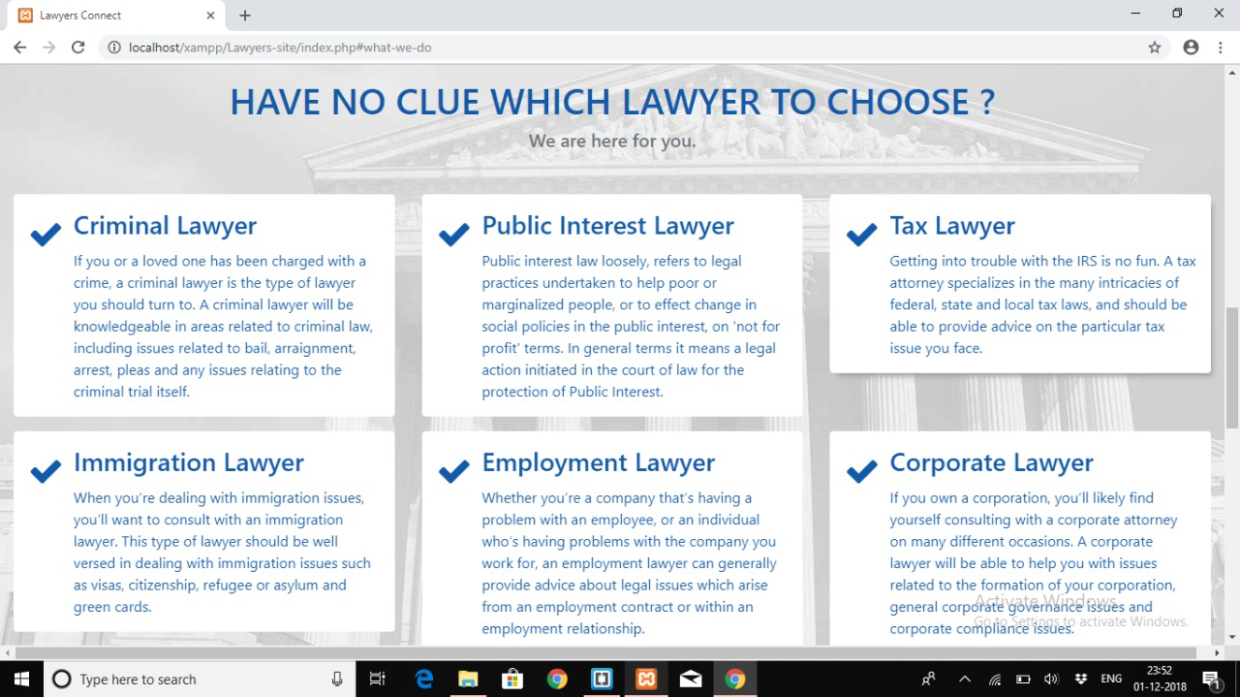

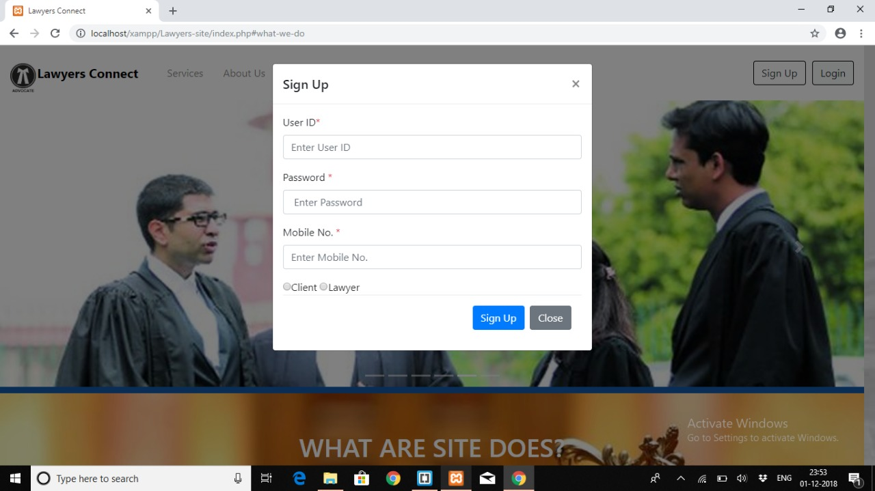

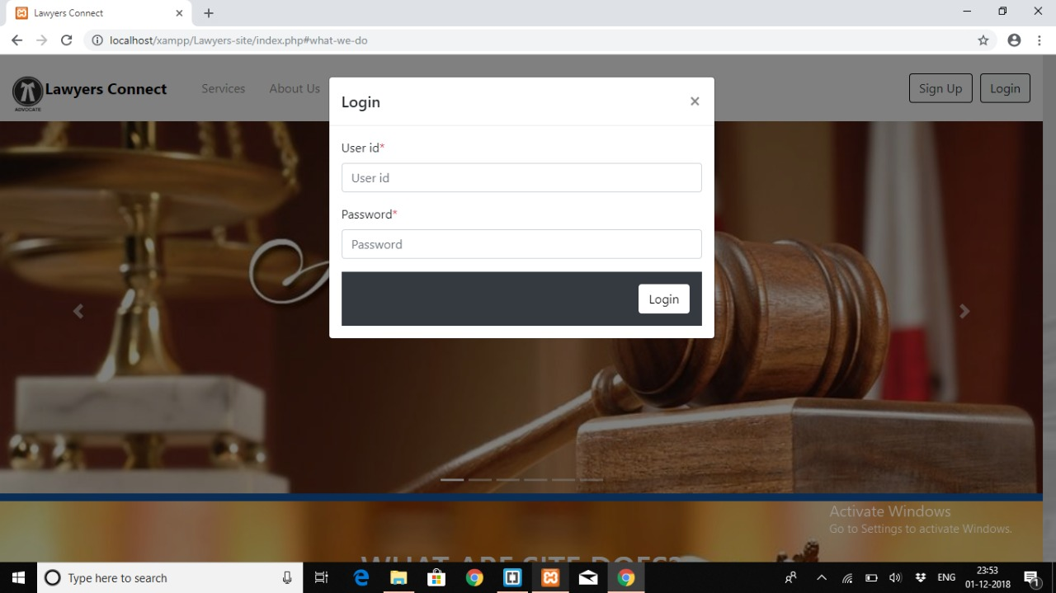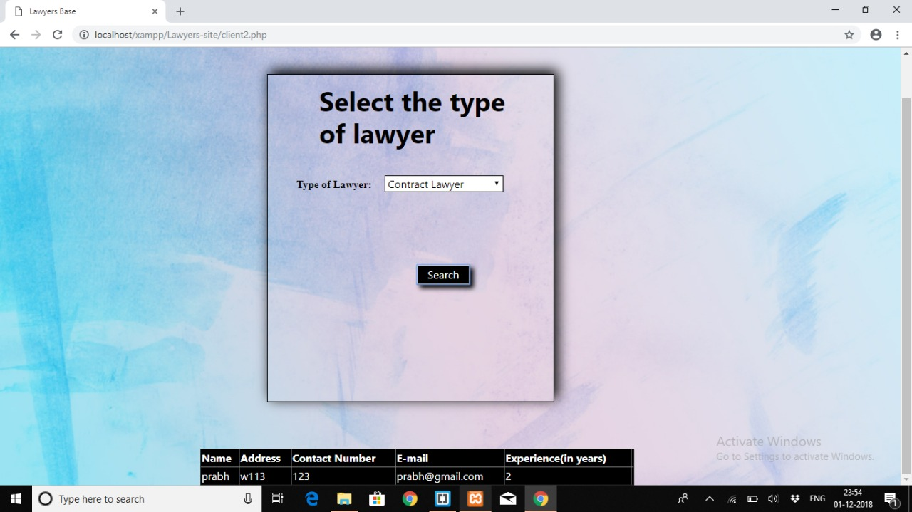

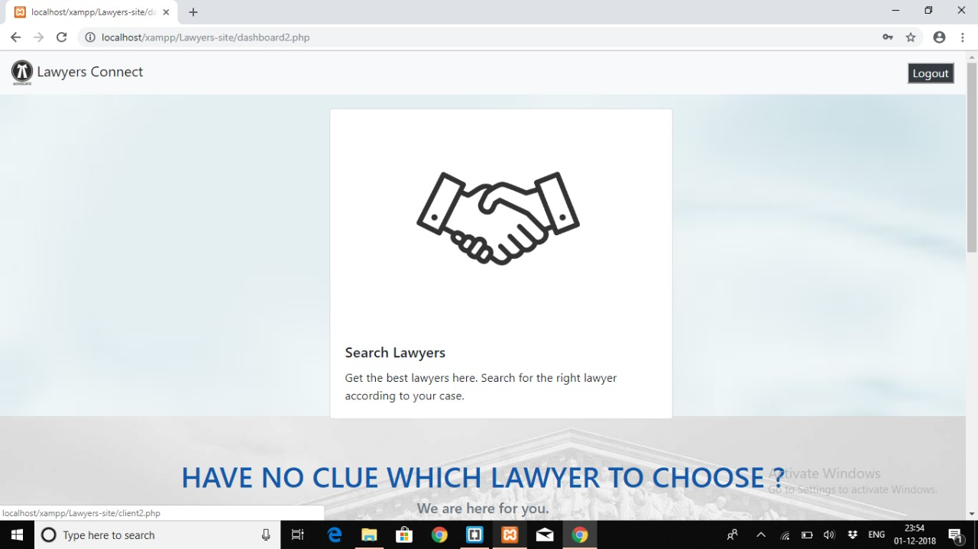

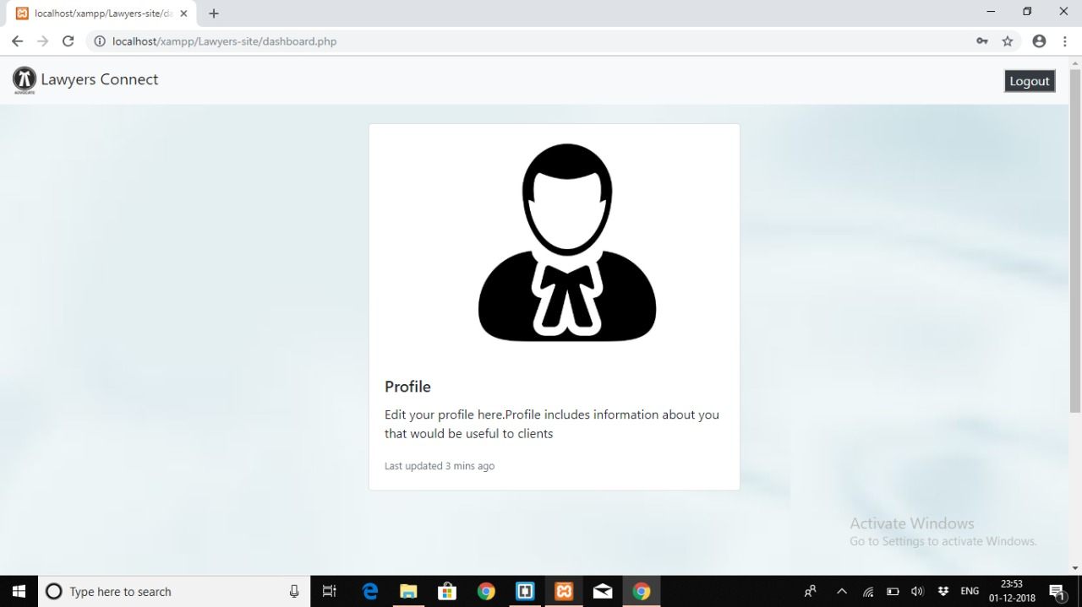

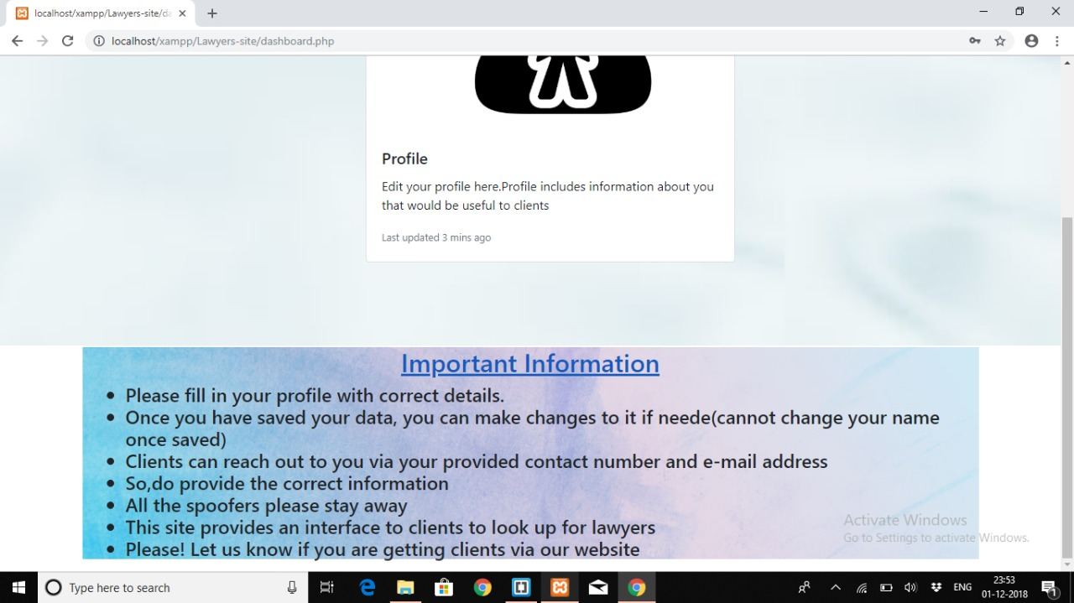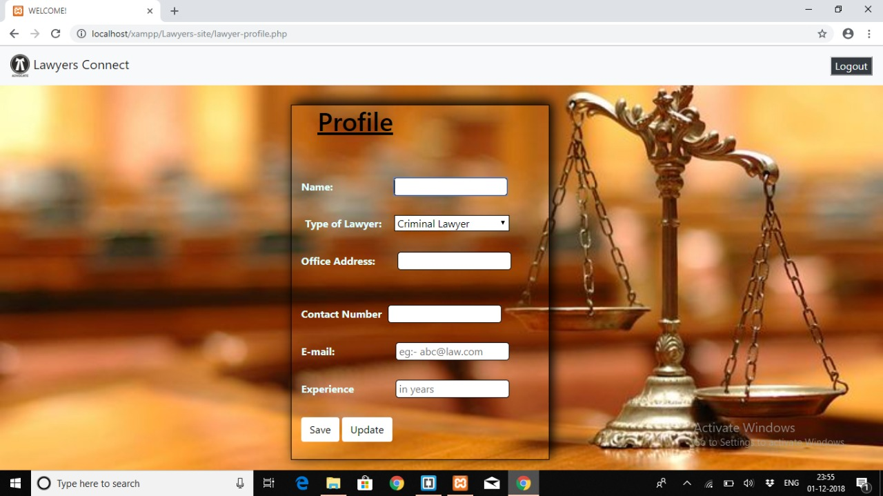

8.**CONCLUSION**

This project that we undertook was truly a very rewarding experience for us. It has given a big thrust to our technical knowledge as prospective software professional .It has also helped us in enhance my skills on the personal front and we feel extremely satisfied by the fact that we have managed to develop the project of course with equal contribution from our team members .

Using this website, Clients can search for various categories of lawyers. Our Project “Lawyers Connect” behaves like a Interface Between a Client and Lawyer. You can access our services by Signing up as a client or lawyer. Clients can communicate with lawyers via their Contact Number and Email Address.

We think we have exploited the opportunity that came our way to the fullest extent by increasing our technical knowledge and also gaining the valuable work experience apart from studying the others subjects in our curriculum.

**9.BIBLIOGRAPHY**

**Websites:**

http://www.Google.com

http://www.w3schools.com/php

http://www.bootsnipp.com

http://www.en.wikipedia.org/wiki/PHP

http://www.tutorialspoint.com/php/